**Hexmaze stitcher installation**

For Windows PCs.

Things you will need to run the stitcher:

* Install Anaconda
* Download FFMPEG and have it in the command line path.
* The stitch.py script. Plus an easy way to run it through a batch file.
* Hexmaze videos to stitch. 12 in total.

**Installing anaconda**

Install the latest Anaconda for Windows 64Bits <https://www.anaconda.com/products/individual>

You will be prompted with multiple questions during installation. Just select the default or recommended options and click next until it is done.

**FMMPEG**

You will need to download FFMPEG. It can be found here:

<https://ffmpeg.org/download.html>

Select the windows EXE files that says: ***Windows builds from gyan.dev***

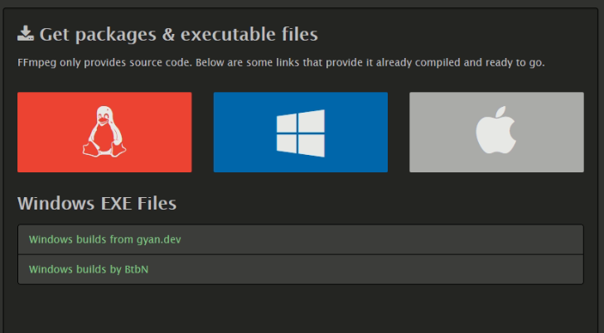

You should be redirected to <https://www.gyan.dev/ffmpeg/builds/>

Look for the release section and select the release-full option with the .7z format.

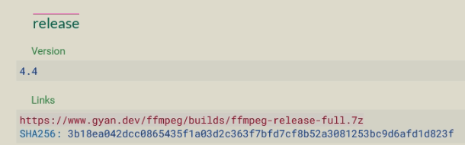

To extract the file, you will need the 7-zip extractor which you can find here.

<https://7-zip.org/download.html>

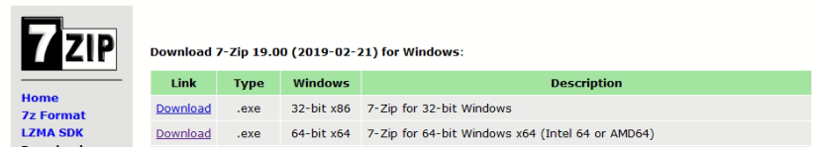

Select the 64-bit .exe file and install.

Once you have 7zip, open the content of the FFMPEG 7Z file and go into the ‘bin’ folder.

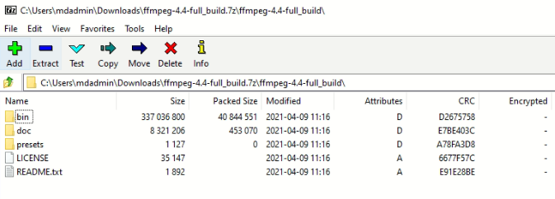

You fill find 3 .exe files.

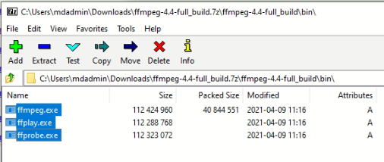

Select them and drag them into a folder of your preference. In my case I created a folder named ‘ffmpeg’ in my Documents, so my path is:

C:\Users\mdadmin\Documents\ffmpeg

Once the three files are in the path. Copy your path and press the Windows Icon on your keyboard and s. Use the search bar to look for: path

You should select the option ‘**Edit the system environment variables**’

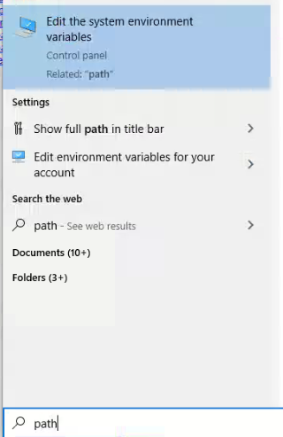

Select environment variables…

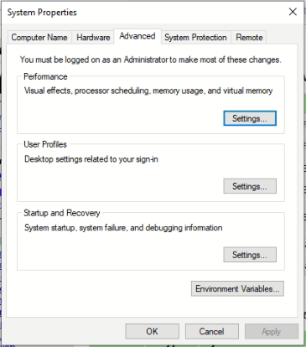

If you are using the admin session in the windows PC:

In environment variables select the Path option in the User variables for your user. Click Edit..

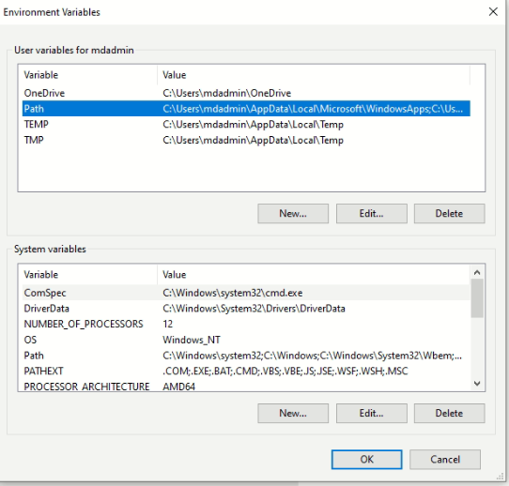

If you are not using the admin session of the computer (you are in a “student” session) use the path from the system variables instead of the path from User variables, like this:

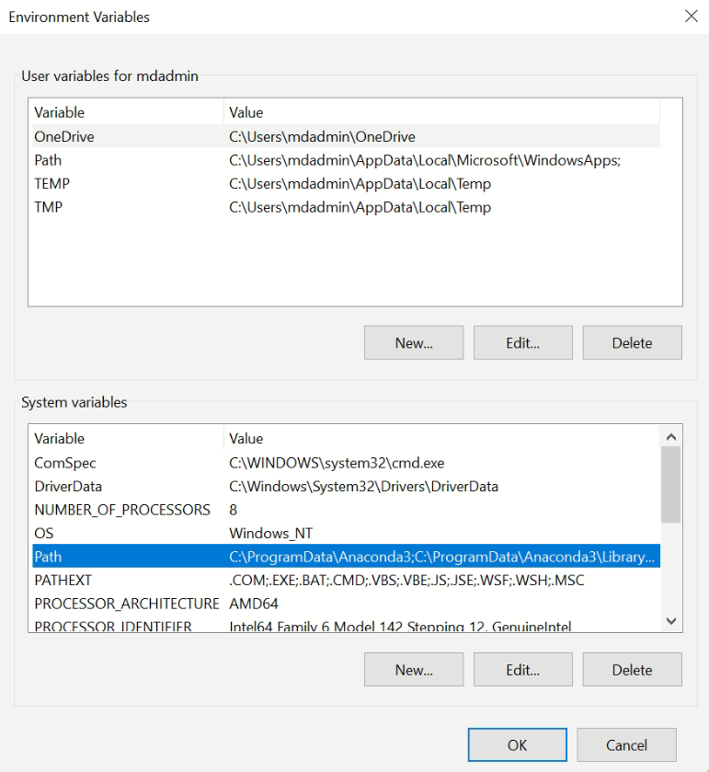

After clicking Edit.. you will see a new window. Click on ‘New’ and paste the path to the folder where you saved the ffmpeg files. Then click OK until all windows are closed.

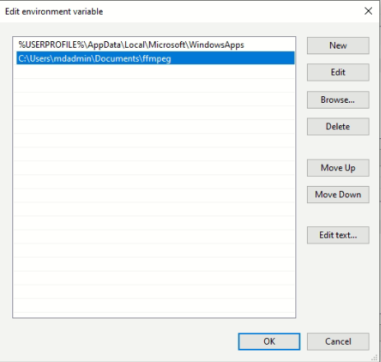

You can confirm that ffmpeg is installed if you press the Windows key and s to search for cmd. Once in the command prompt type: ffmpeg . It should look this way:

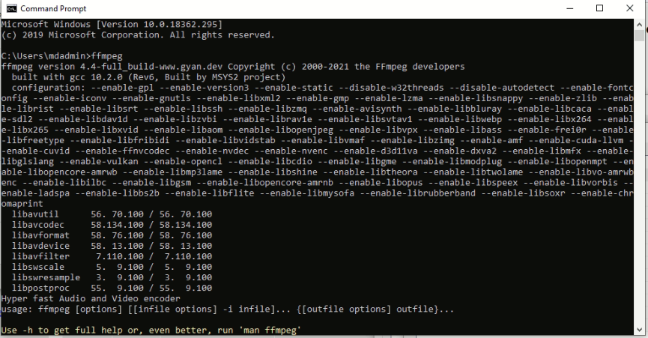

The installation should be complete. But now we need a way to run the script easily.

For this we will create a batch file to execute the script.

Open a new notepad and paste the following:

@echo off

python C: \Path To Your Directory\stitch.py %*

pause

Replace Path To Your Directory with the actual and complete path of the directory where you have the stitch.py file. Now save the file in your directory as: **stitch.bat**

The batch file is ready but we would like to run it from any location in the computer. For that we need to add it to the path:

set PATH=%PATH%;C: \Path To Your Directory\

Again, replace Path To Your Directory with the actual and complete path of the directory where you have the stitch.py file and your stitch.bat file.

If that does not work go back to ‘**Edit the system environment variables**’ and add the path to the .bat file as a new path similarly as how you did with ffmpeg.

It should be done!

Now just go to the command prompt (cmd) and type:

stitch /path_to_folder_with_videos/